PROJECT NAME

eatsure.com

HOME PAGE ONLY

**Overview of the Project:-**

**The main objective of the Project on Online Food Ordering System is to manage the details of Food Item, Category, Customer, Order, Confirm Order. It manages all the information about Food Item, Payment, Confirm Order, Food Item. The project is totally built at administrative end and thus only the administrator is guaranteed the access. The purpose of the project is to build an application program to reduce the manual work for managing the Food Item, Category, Payment, Customer. It tracks all the details about the Customer, Order, Confirm Order**

**Functionalities provided by Online Food Ordering System are as follows:**

**1: Provides the searching facilities based on various factors. Such as Food Item, Customer, Order, Confirm Order**

**2: Online Food Ordering System also manage the Payment details online for Order details, Confirm Order details, Food Item.**

**3: It tracks all the information of Category, Payment, Order etc**

**4Manage the information of Category**

**5: Shows the information and description of the Food Item, Customer**

**6: To increase efficiency of managing the Food Item, Category**

**7:It deals with monitoring the information and transactions of Order**

**Home Page**

**Header**

**1: Select Location**

**2: Search bar**

**3: Help**

**4: Cart**

**5: Sign In**

**6: Hamburger Menu**



**Carousel**

**Explore Items Section**

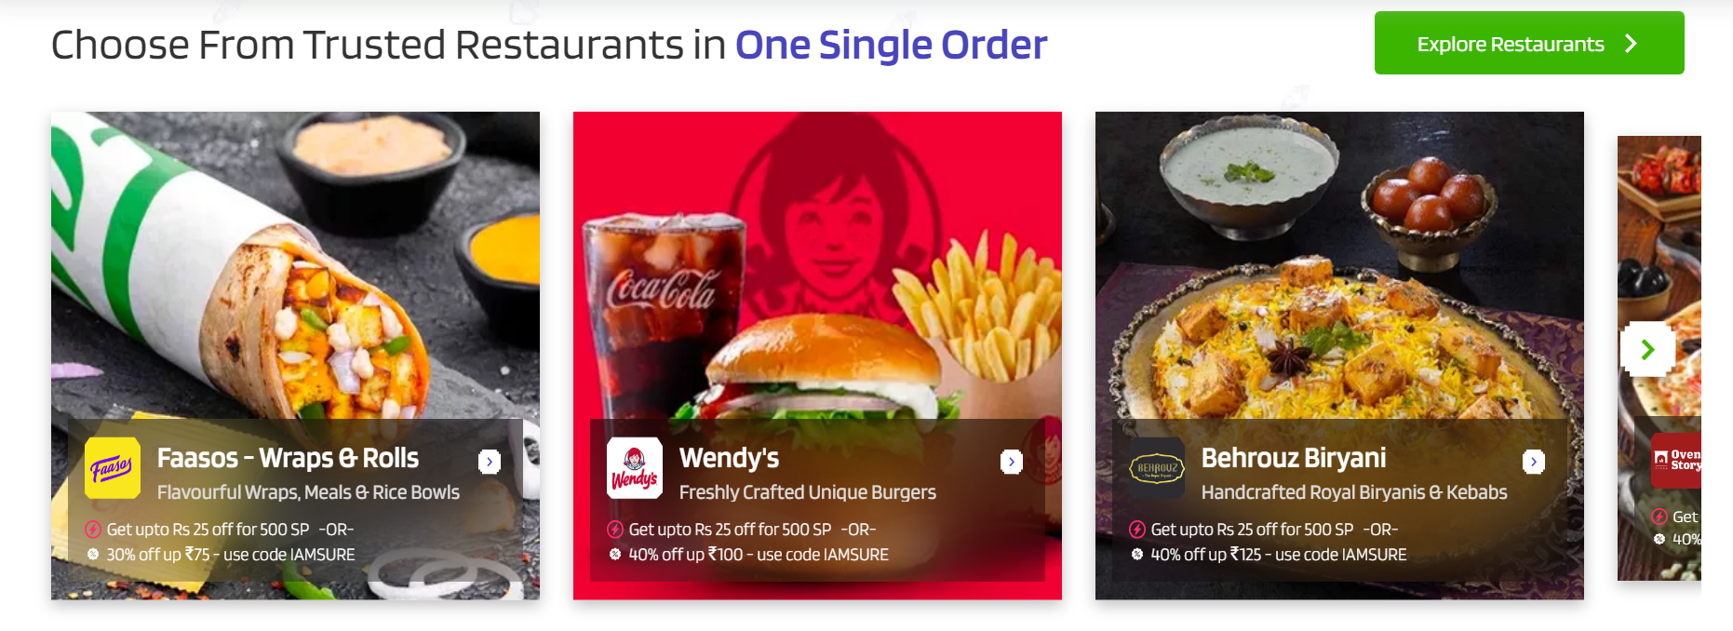

**Sure Saving Carousel**

**Most Loved Collection Section:**

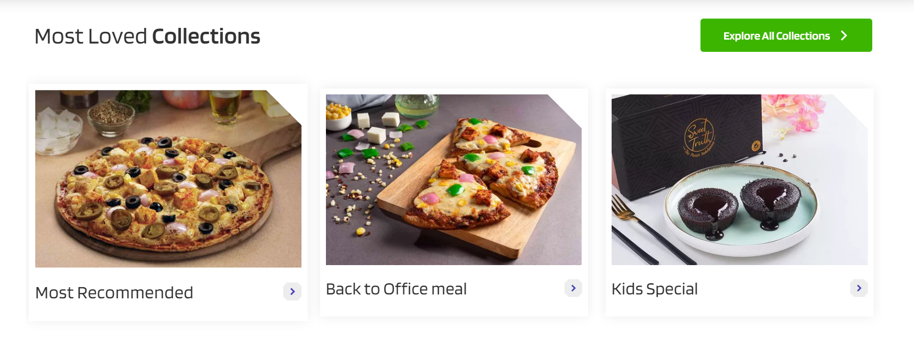

Explore All Combos

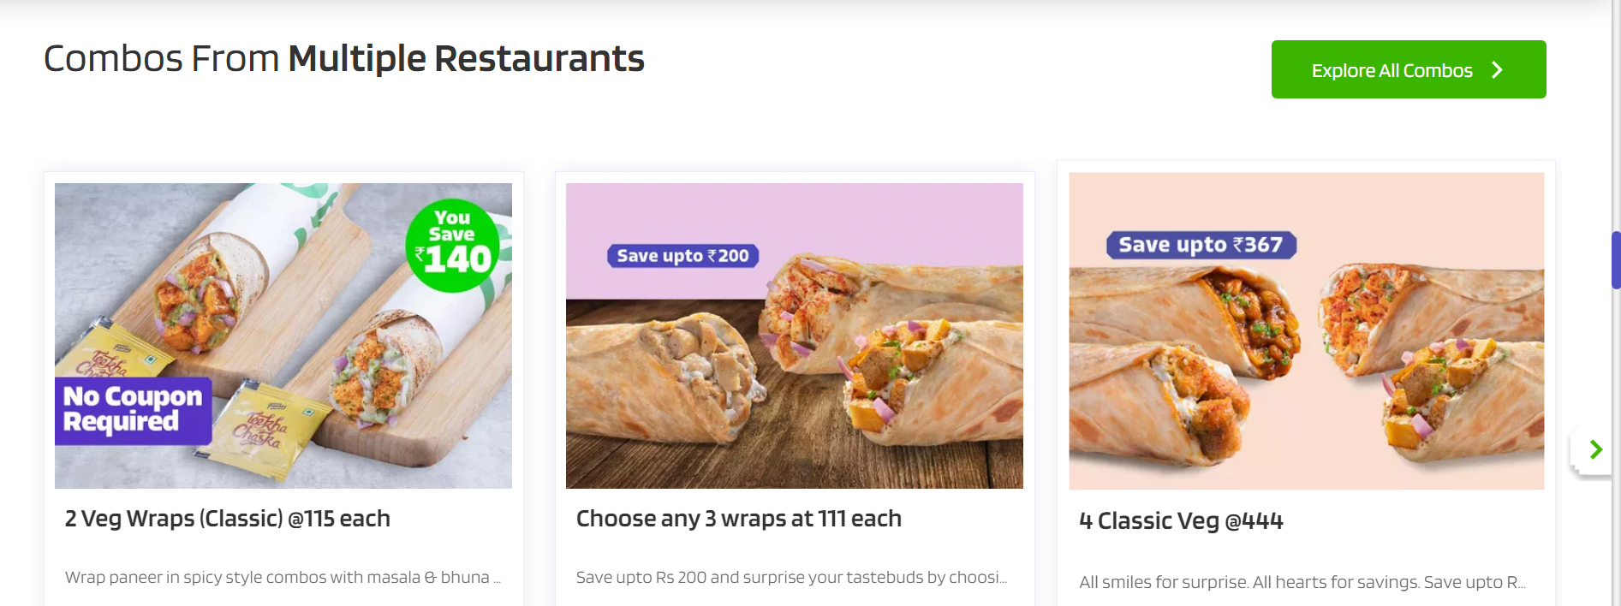

Give Sure Section

Eatsure Download Section

Footer Section:

